Practical – 5
Practical Title: Registration Form with Frontend Validation and User-Friendly Error Handling
Problem Definition: Create a student registration form with HTML5 input types and JavaScript validation for name, email, mobile number, password, confirm password, course, year, gender, and terms acceptance. Use Regular Expression for validations.
Theory :
1. Are correct input types and attributes used?
Yes, correct input types such as text, password, email, number, and date are used. The required attribute is also used to make important fields mandatory.
2. Are validation errors displayed near the relevant fields?
Partially, validation messages are displayed using alert() and some messages are displayed using JavaScript. For better usability, errors can be displayed directly near the relevant fields.
3. Is password strength checked?
Yes, password strength is checked using Regex in JavaScript. The password must contain at least 8 characters, one letter, and one number.
4. Is the form accessible using keyboard and screen-reader-friendly labels?
Yes, proper <label> tags with for attributes are used for the form fields. This helps users navigate the form using the keyboard and makes it more understandable for screen readers.

Implementation/ Output/Result validation of password and Email id using Regex: (Pages with JS)
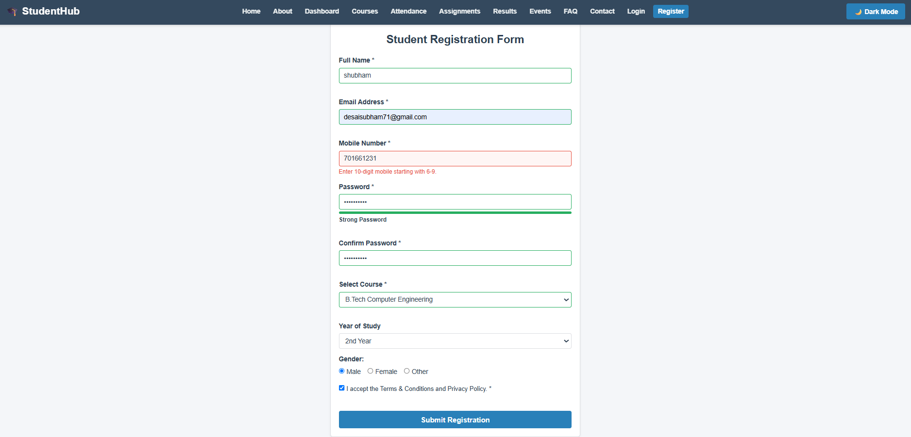
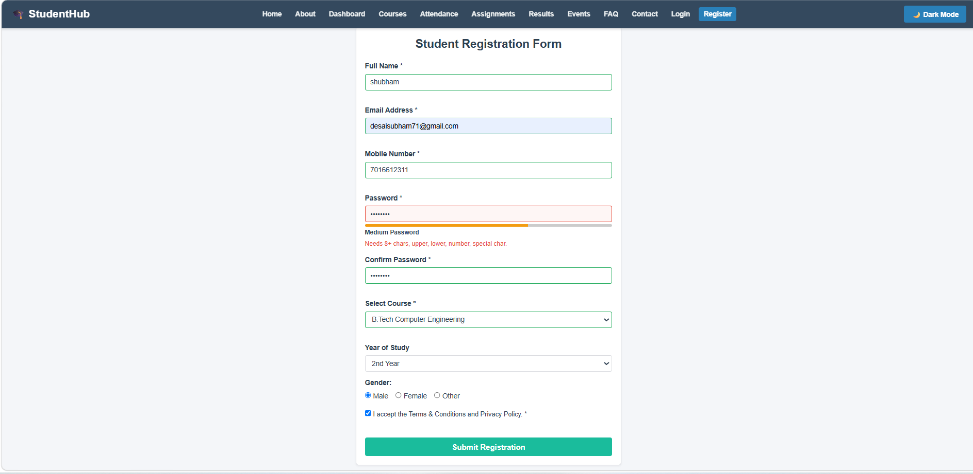
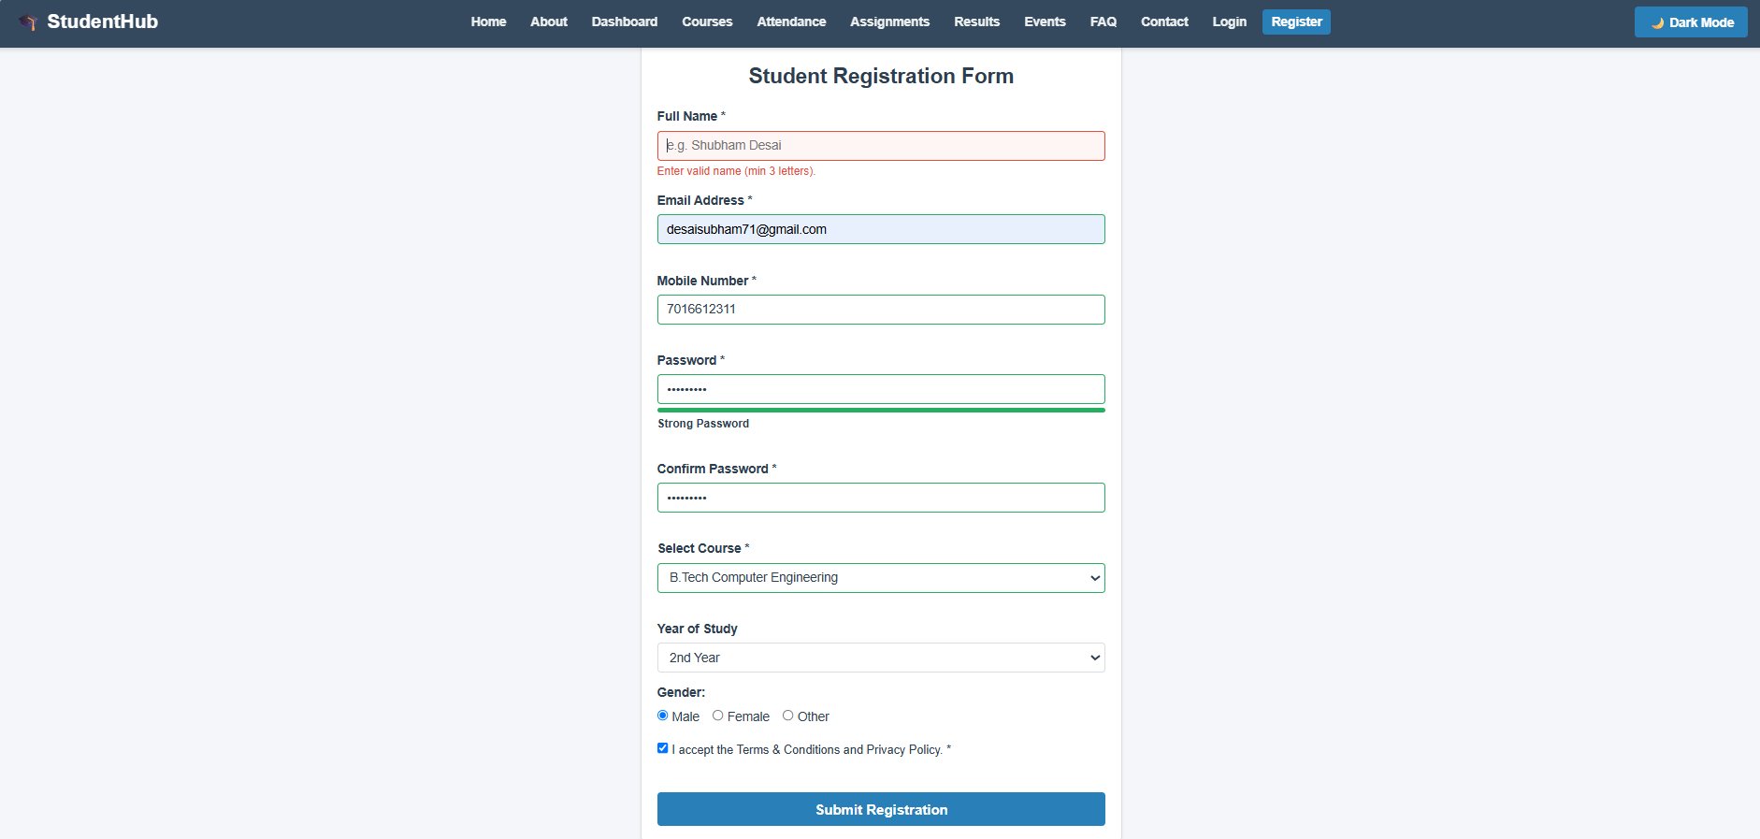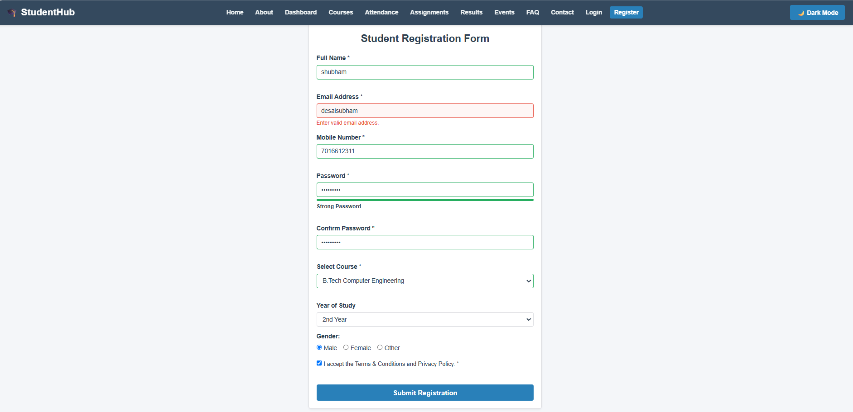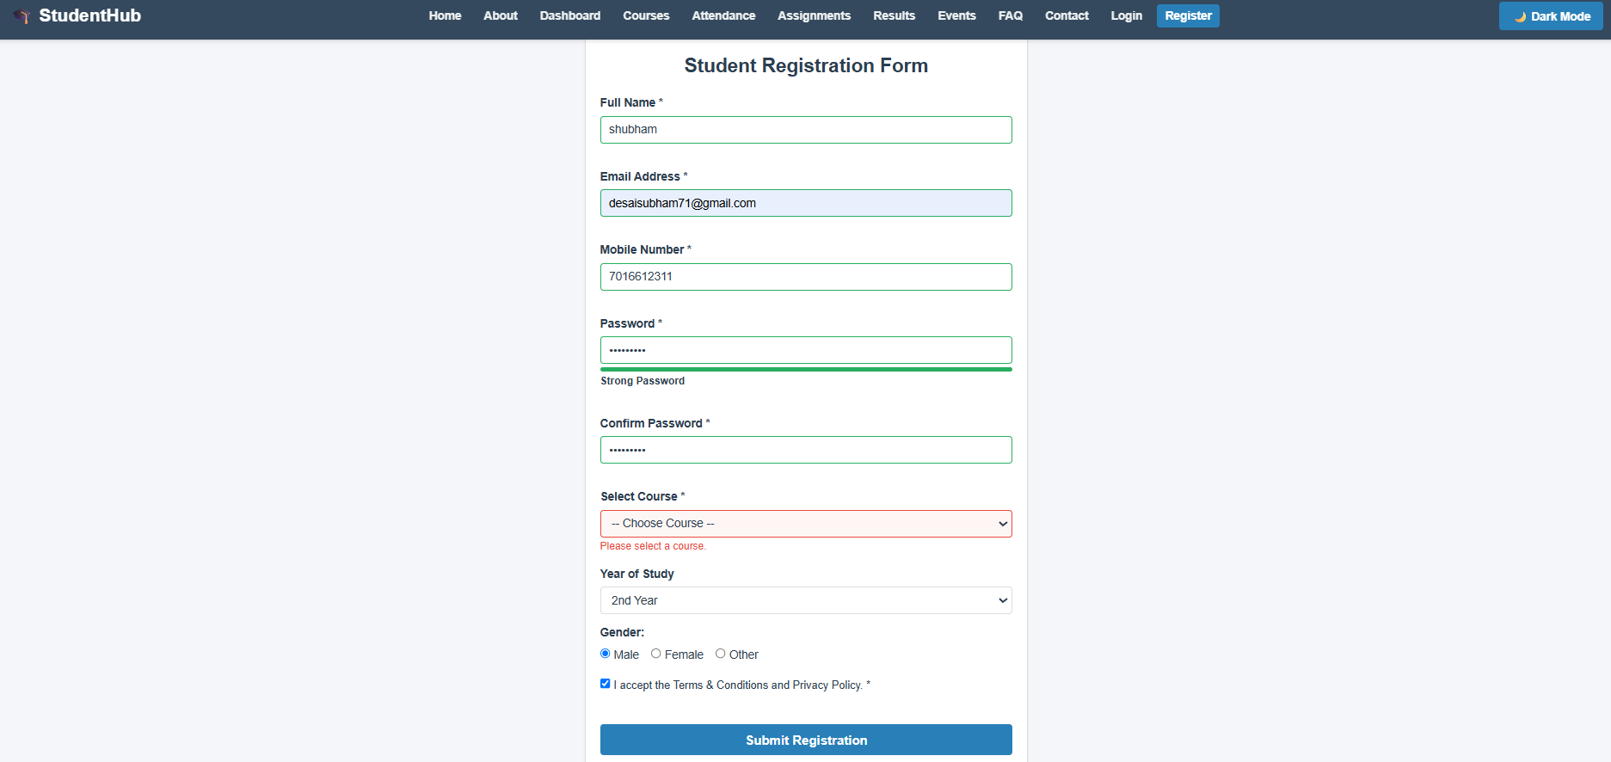
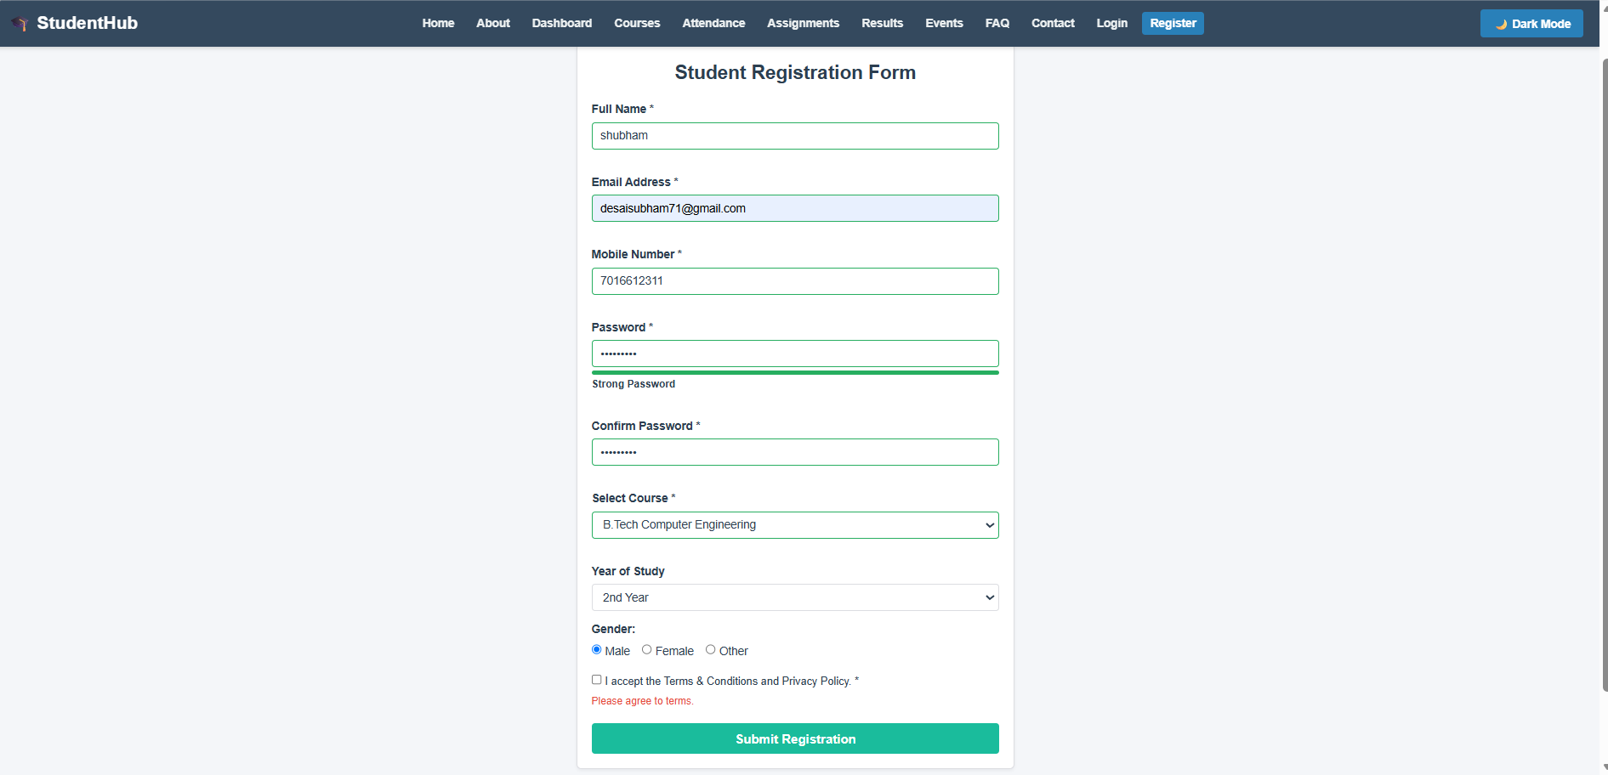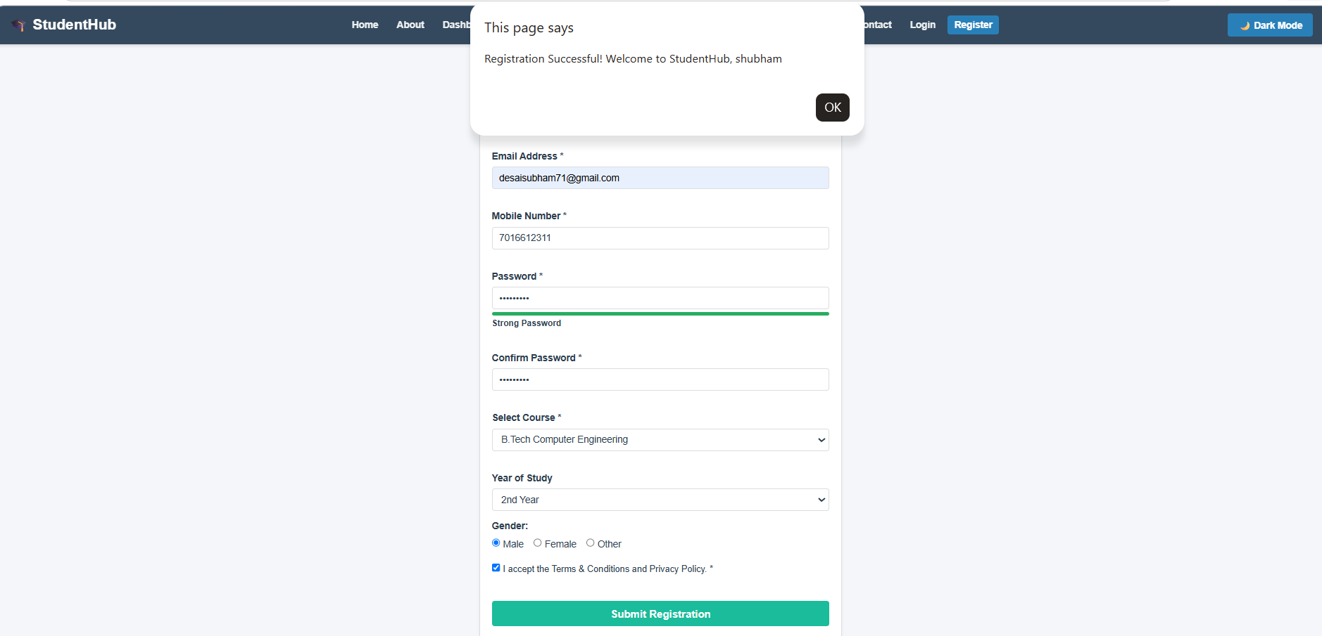

GitHub Repository Link:
https://github.com/Shubham-desai07/Studenthub-portal.git

Learning Outcomes:
After completing this practical, I learned:

- To use JavaScript DOM manipulation for selecting and modifying HTML elements.
- To handle user events such as button clicks using addEventListener().
- To perform form validation using JavaScript and Regex for password and email.
- To create a more interactive and user-friendly website.
- To improve the usability, validation, and interactivity of the Student Hub Portal.

Faculty Remarks: (Keep this blank for faculty)

